Senior Project:

Omaha

Chris Burgess and Dheric Seney

Senior Project: COMP 5500-1

Charlie Pham

31 May 2019

Senior

Table of Contents:

1. **Introduction …………………………………………………………………………….. 3**
   1. Purpose
   2. Scope
   3. Definitions, Acronyms, and Abbreviations
   4. References
2. **Use Cases …………………………………………………………………………........... 4**
   1. Use Case Diagrams
3. **Design Overview ………………………………………………………………………... 6**
   1. System Architecture
   2. System Interface
   3. Constraints and Assumptions
4. **Data Design ……………………………………………………………………………7-8**
   1. Entity Relationship Diagram
5. **Non-functional Requirements ………………………………………………………..... 8**

Software Design Document

1. **Introduction**

The National Football League is an American Football League that has 32 teams that face off against each other every year. During the games the NFL records data of every player no matter the role they have on the team. Using the stats the NFL and other websites create a virtual game called Fantasy Football that allows anybody to play the role as a manager for a virtual team and face off against other people. Similar to creating a virtual football team, Paul Depodesta, Chief Strategy Officer for the Cleveland Browns, uses statistics and analyzes players for potential on creating a good real life team. Therefore, what would happen if you combine real-time player analysis/statistics and use the knowledge to give feedback to people who play fantasy football.

* 1. Purpose: Omaha is a web application that will help users. It will allow users to see different statistic about different players. It will also give them strategies and helpful advice to build a Fantasy Football Team.
  2. Scope:

Omaha will aim to assist people who have had trouble building Fantasy Football teams in the past. This app can be used for daily fantasy football, weekly fantasy football, and league fantasy football. The program will give users an advantage over their competition and the potential to win their games and league.

* 1. Definitions, Acronyms, and Abbreviations

Fantasy Football - game where people can play as manage a virtual team on a weekly basis

Draft - the process in fantasy football where people take turns picking players for their team

Rookie - a first year professional football player

NFL - National Football League

* 1. References
* https://fantasy.nfl.com/
* http://www.espn.com/fantasy/football/
* https://www.cheatsheetwarroom.com/blog/fantasy-football/site/best-advice
* https://thisisstatistics.org/statistics-behind-fantasy-football/
* https://www.rotostreetjournal.com/stockformula/

1. **Use Cases**
   1. Use Case Diagrams

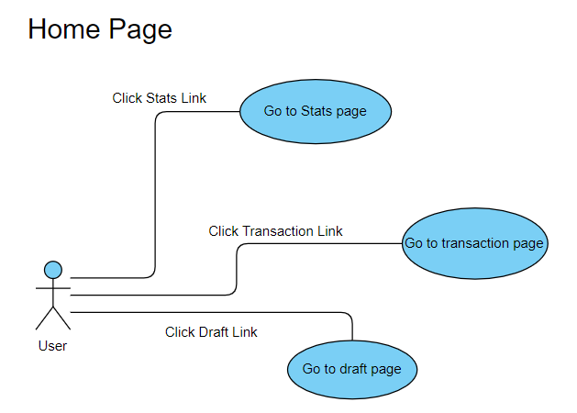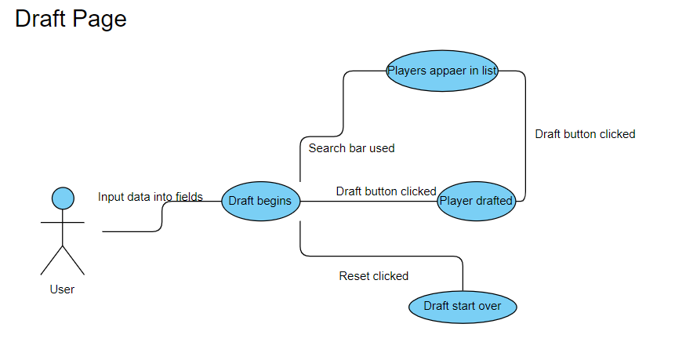

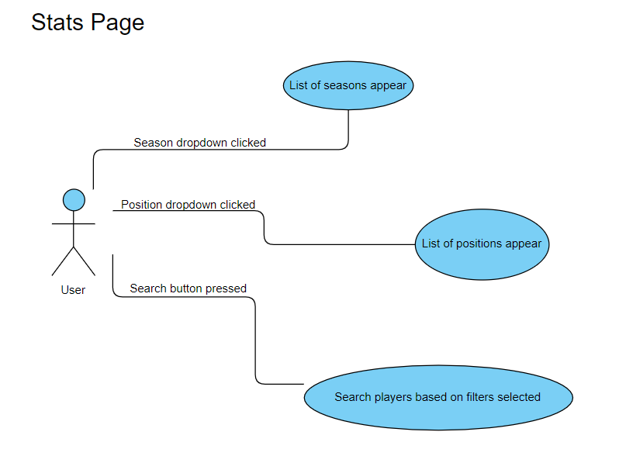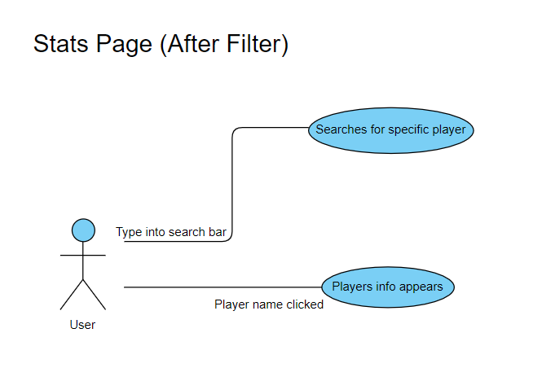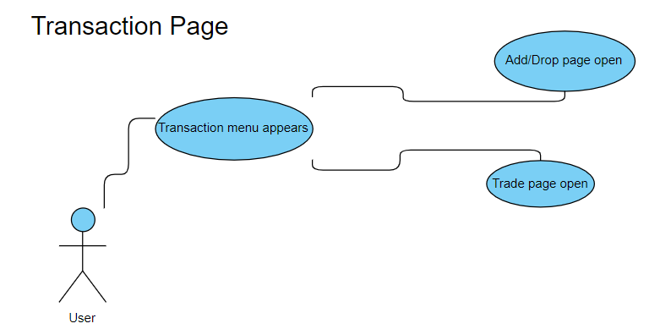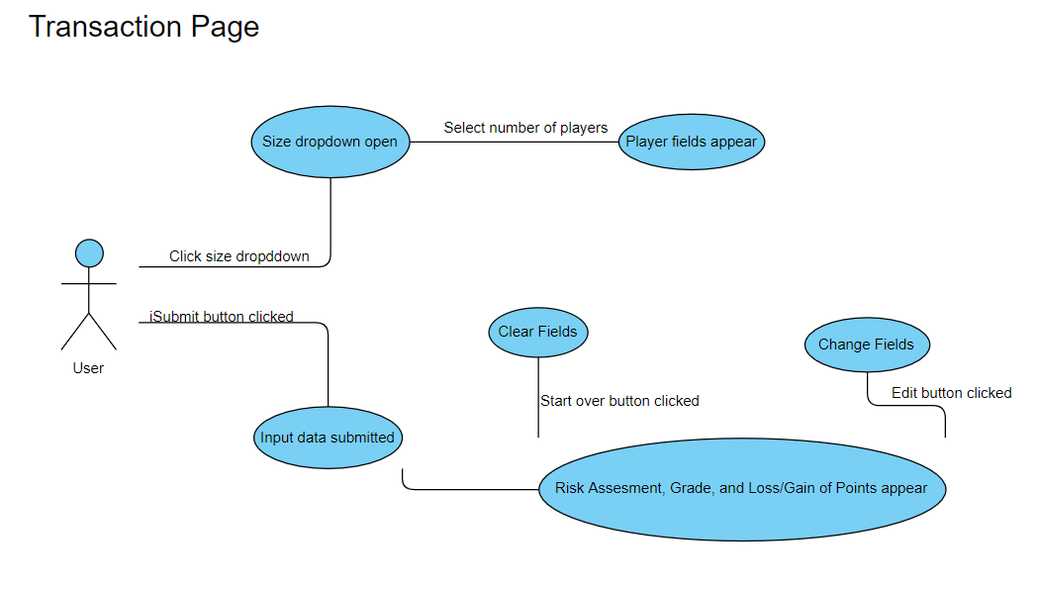

1. **Design Overview**
   1. System Architecture

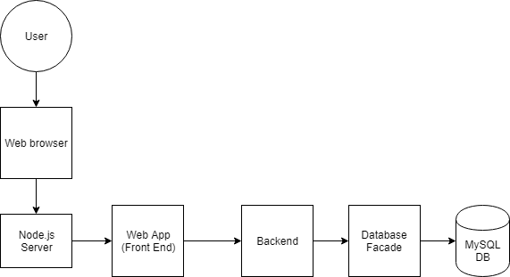

* 1. System Interface
     1. User Interfaces

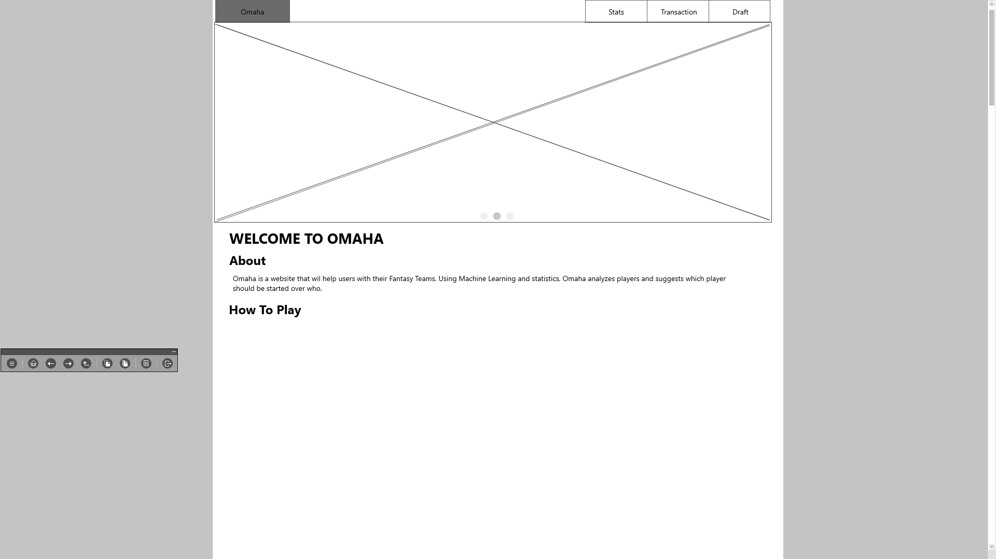

The user interface for the system will allow the user to navigate through the website. The user will have a choice to view players stats, get feedback on a transaction they want to make, and get advice when drafting a fantasy football team.

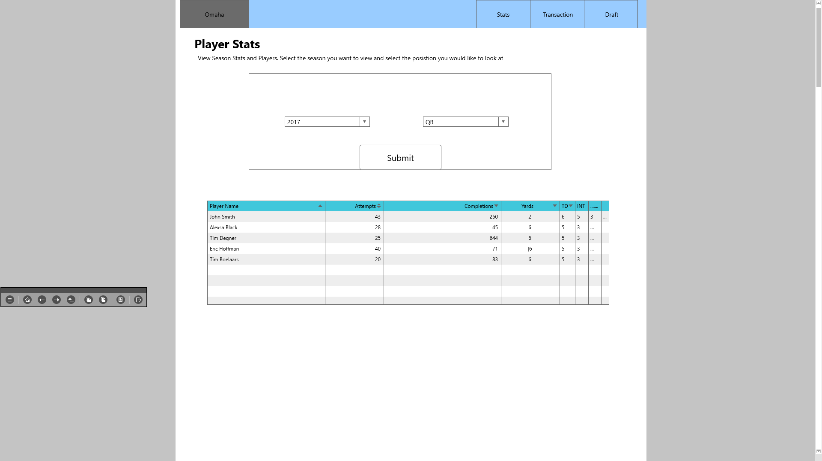

When a user navigates to the player stat page, the user will see every players stats to a certain amount of time. From there, they can search for different players by name, get individual player stats when they click on a name, and filter out the player table by position, name, and etc.

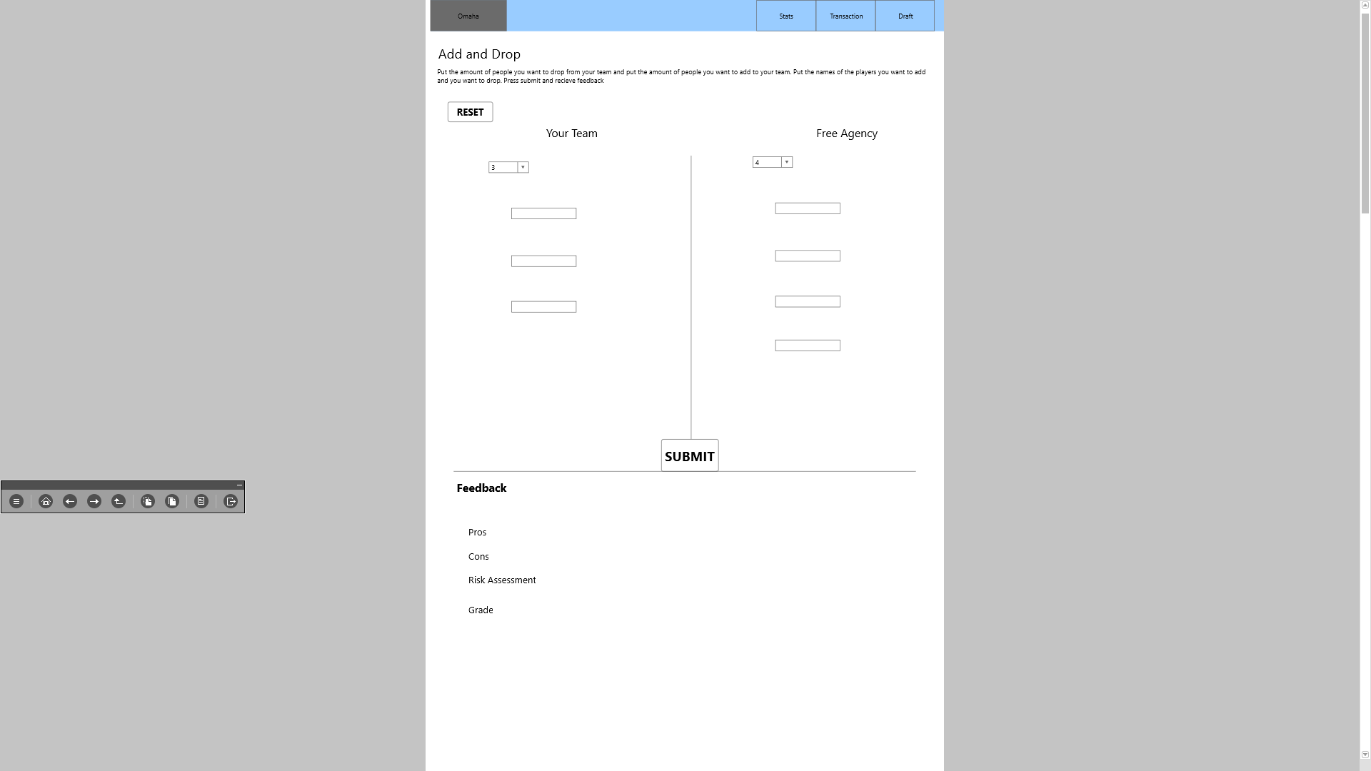

When a user navigates to the transaction page, they will have a choice to choose from add/drop or trade. When they choose an option, they can input player names from their team and players they will get in the transaction. From there, the system will give the user advice on whether its is a good transaction they are doing.

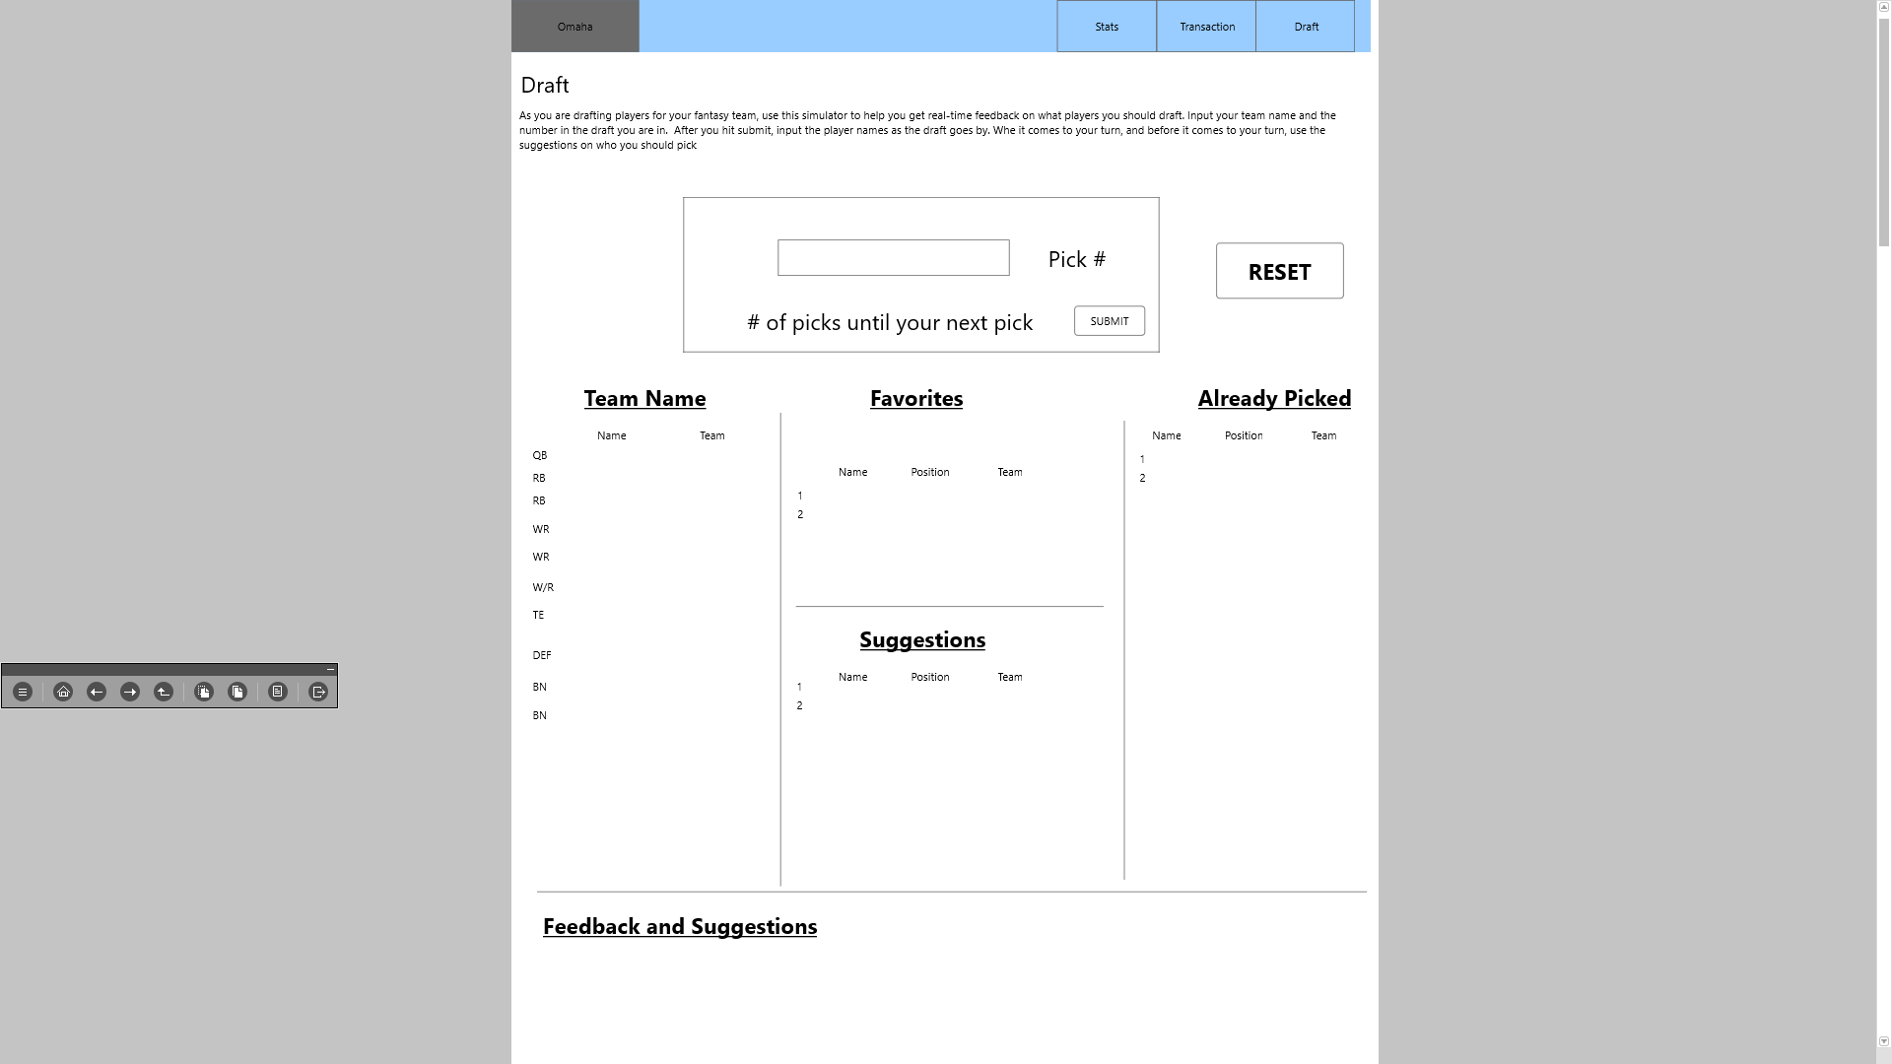

When the user navigates to the draft page, the user will be able to get feedback and suggestions on what players they should draft. They will input their team name and pick number and from there they will input player names after each player is taken in their draft. During the process, the website will give feedback and suggestions to the user.

* + 1. Software Interfaces

The software will communicate back and forth with the database. It will pull data from the database based on specific queries and actions.

-Get career totals:

**SELECT**

`first_name`,`last_name`,`pass_yds`, `rush_yds`, `receive_yds`,`fieldgoal`, `pat`, `kick_rtn`, `rush_td`, `pass_td`,`receive_td`,`interceptions`

**From** career_total, players

**WHERE** career_total.player_id = players.player_id

-Get yearly stats:

**SELECT**

`first_name`,`last_name`,`Year`,`Team`,`game_won`,`player_team_score`,`opponent_score`,`passing_attempts`,`passing_completions`,`passing_yards`,`passing_rating`,`passing_touchdowns`,`passing_interceptions`,`passing_sacks`,`passing_sacks_yards_lost`,`rushing_attempts`,`rushing_yards`,`rushing_touchdowns`,`receiving_targets`,`receiving_receptions`,`receiving_yards`,`receiving_touchdowns`,`kick_return_attempts`,`kick_return_yards`,`kick_return_touchdowns`,`point_after_attempts`,`point_after_makes`,`field_goal_attempts`,`field_goal_makes`

**From** offense_stats, players

**WHERE** offense_stats.player_id = players.player_id

-Get averages of yearly stats:

**SELECT** `first_name`,`last_name`,`Team`,AVG(`game_won`),Avg(`player_team_score`),Avg(`opponent_score`),Avg(`passing_attempts`),Avg(`passing_completions`),AVG(`passing_yards`),Avg(`passing_rating`), Avg(`passing_touchdowns`), Avg(`passing_interceptions`), Avg(`passing_sacks`), AVg(`passing_sacks_yards_lost`), avg(`rushing_attempts`), avg(`rushing_yards`), avg(`rushing_touchdowns`), avg(`receiving_targets`), avg(`receiving_receptions`), avg(`receiving_yards`), avg(`receiving_touchdowns`), avg(`kick_return_attempts`), avg(`kick_return_yards`), avg(`kick_return_touchdowns`), avg(`point_after_attempts`), avg(`point_after_makes`), avg(`field_goal_attempts`), avg(`field_goal_makes`)

**From** offense_stats, players

**WHERE** offense_stats.player_id = players.player_id

**Group By** offense_stats.player_id

* 1. Constraints and Assumptions
     1. List of Assumptions
        1. The user will be able to navigate between different pages on the website without any pages being missing
        2. All text and images should appear on each page of the website
        3. The user has proper knowledge of what fantasy football is or knows the basics to it. They are also familiar with most of the current NFL players playing
     2. List of Dependencies
        1. The system is dependent on the database. If the database does not connect to the website/web pages, there will be no data displayed on either page. The queries designed to pull the data from the database are important in this case.
        2. The use of machine learning will be important for the website. We will use machine learning to give feedback to users who use the website. When a user wants to add and drop players. Using machine learning, we will give them information on what risks they will take when they perform the transaction. For example, the site will give them a grade, expected points that they will lose or gain when they have the trade. The site will also show predicted stats for the players. Another feature that will use machine learning is whether a user should start or sit a player. The user will choose two players they cannot decide on who to start. The site will give feedback on who to start.
           1. Possible Machine Learning Methods:

K-Nearest Neighbors

Decision Trees

Classification

Regression

Clustering

Mode Select

etc.

1. **Data Design**
   1. Entity Relationship Diagram

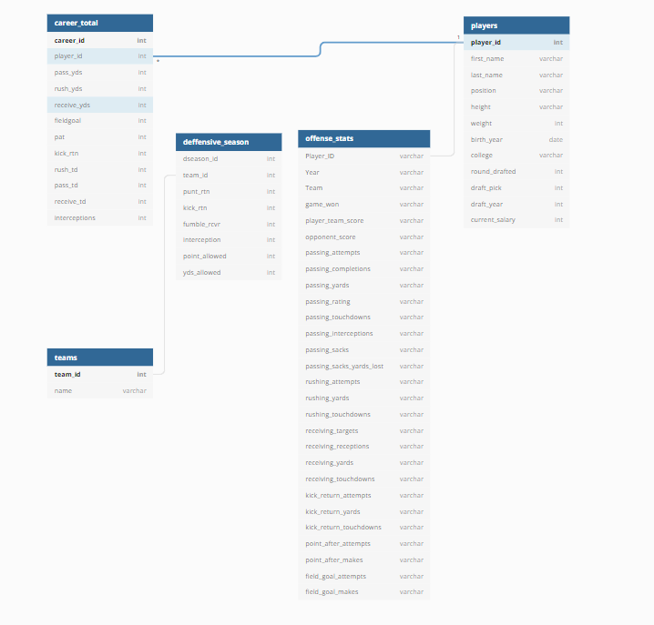

1. **Non-functional Requirements**
   1. Rookie Page

A feature that will project rookie stats for the upcoming football season

* 1. Defensive players

A feature that will allow a user to see individual defensive player stats.

* 1. Import Teams

A feature that will allow a user to import their team into the websites database so they do not have to keep plugging in their players each time they do a transaction

[SELECT](http://localhost/phpmyadmin/url.php?url=https://dev.mysql.com/doc/refman/5.5/en/select.html) `first_name`,`last_name`,`pass_yds`, `rush_yds`, `receive_yds`,`fieldgoal`, `pat`, `kick_rtn`, `rush_td`, `pass_td`,`receive_td`,`interceptions`

From career_total, players

WHEREcareer_total.player_id = players.player_id

SELECT `first_name`,`last_name`,`Year`,`Team`,`game_won`,`player_team_score`,`opponent_score`,`passing_attempts`,`passing_completions`,`passing_yards`,`passing_rating`,`passing_touchdowns`,`passing_interceptions`,`passing_sacks`,`passing_sacks_yards_lost`,`rushing_attempts`,`rushing_yards`,`rushing_touchdowns`,`receiving_targets`,`receiving_receptions`,`receiving_yards`,`receiving_touchdowns`,`kick_return_attempts`,`kick_return_yards`,`kick_return_touchdowns`,`point_after_attempts`,`point_after_makes`,`field_goal_attempts`,`field_goal_makes`

From offense_stats, players

WHERE offense_stats.player_id = players.player_id

SELECT `first_name`,`last_name`,`Team`,AVG(`game_won`),Avg(`player_team_score`),Avg(`opponent_score`),Avg(`passing_attempts`),Avg(`passing_completions`),AVG(`passing_yards`),Avg(`passing_rating`),

Avg(`passing_touchdowns`),Avg(`passing_interceptions`),Avg(`passing_sacks`),AVg(`passing_sacks_yards_lost`),avg(`rushing_attempts`),avg(`rushing_yards`),avg(`rushing_touchdowns`),

avg(`receiving_targets`),avg(`receiving_receptions`),avg(`receiving_yards`),avg(`receiving_touchdowns`),avg(`kick_return_attempts`),avg(`kick_return_yards`),

avg(`kick_return_touchdowns`),avg(`point_after_attempts`),avg(`point_after_makes`),avg(`field_goal_attempts`),avg(`field_goal_makes`)

From offense_stats, players

WHERE offense_stats.player_id = players.player_id

Group By offense_stats.player_id